Name: Click here to enter text. | Date: Click here to enter a date.

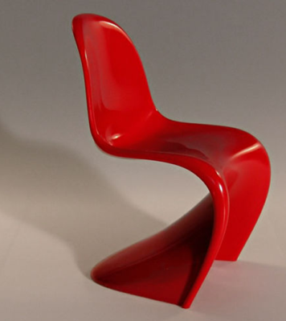
A2 Revision – Panton Chair
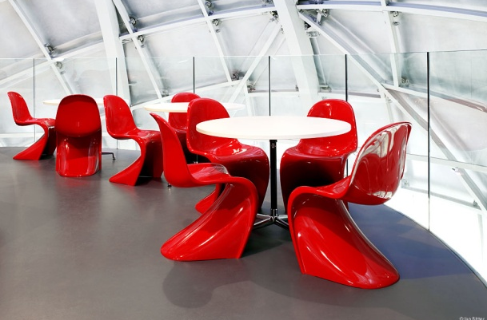
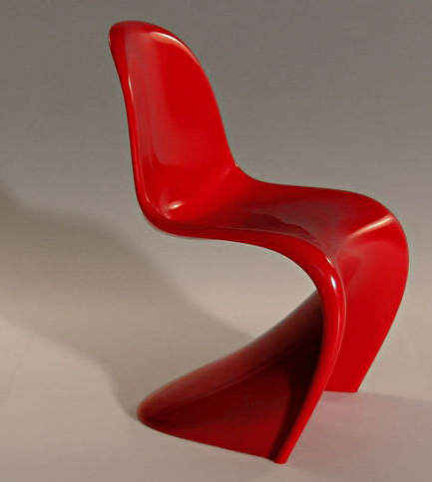
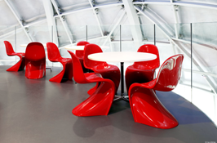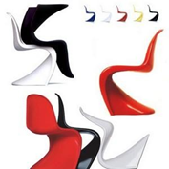
The Panton Chair is an S-shaped chair first designed by the Danish designer Verner Panton in the 1960s. Panton had dreamt of making a stackable, cantilevered plastic chair all in one piece. It is said he had been inspired in particular by a neatly stacked pile of plastic buckets. It is considered the world's first moulded plastic chair and to be a masterpiece of Danish design.
The chair went into production in 1967. The first models were made out of fibreglass-reinforced polyester. It became apparent with time that the material was susceptible to fatigue and breakage. For this reason, production was suspended.
Today’s Panton Chairs are manufactured out of polypropylene using modern injection moulding methods.
Explain the advantages of manufacturing Panton Chair’s out of polypropylene using modern injection moulding methods.
Click here to enter text.

