Science Transition document
- What is the essential knowledge/understanding that they will need to access your subject at the start of Year 7
- Project/research/investigation into your subject
- Some interesting/useful websites/links/videos etc
- Books that they should have read by the end of Year 6?

1 – Document attached to email: ‘Science Key ideas summary’
2 – Science at home project. Instructions and exemplar attached to email: ‘How does science work?’
3 – Websites and videos:
https://www.natgeokids.com/uk/category/discover/science/

https://www.scienceforkidsclub.com/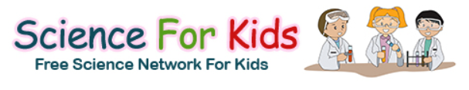
Horrible Science – available on YouTube:
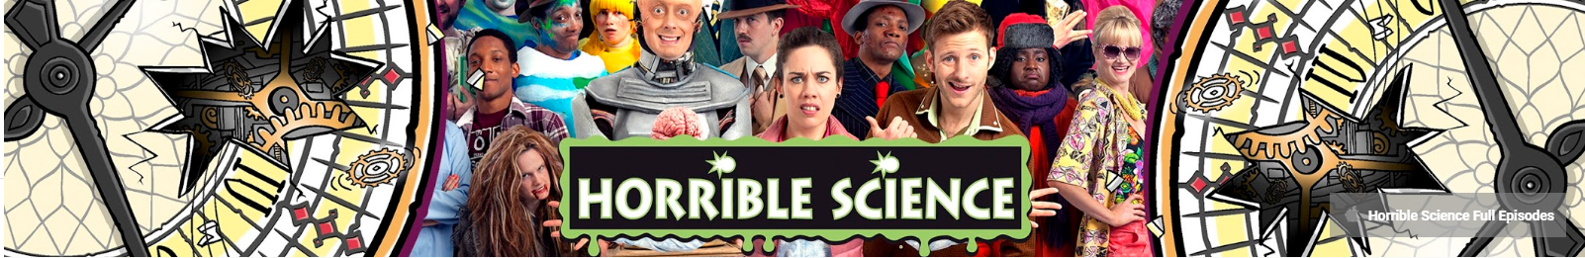

Blue Planet Revisited – available on BBC iPlayer: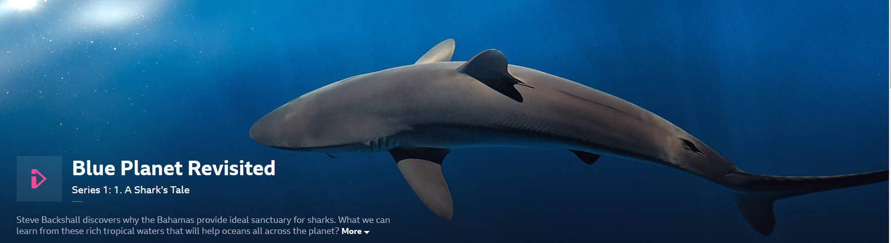
The Planets - available on BBC iPlayer:
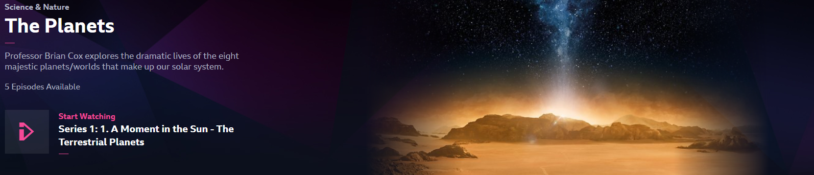

4 – Books. I wouldn’t say these have to be read (as they are not cheap and libraries are not fully open), but I would recommend the following:
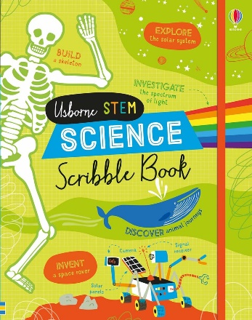
Investigate forces, turbines, mirror writing, skeletons, animal migration and lots more, all using only the book and your pencil case.
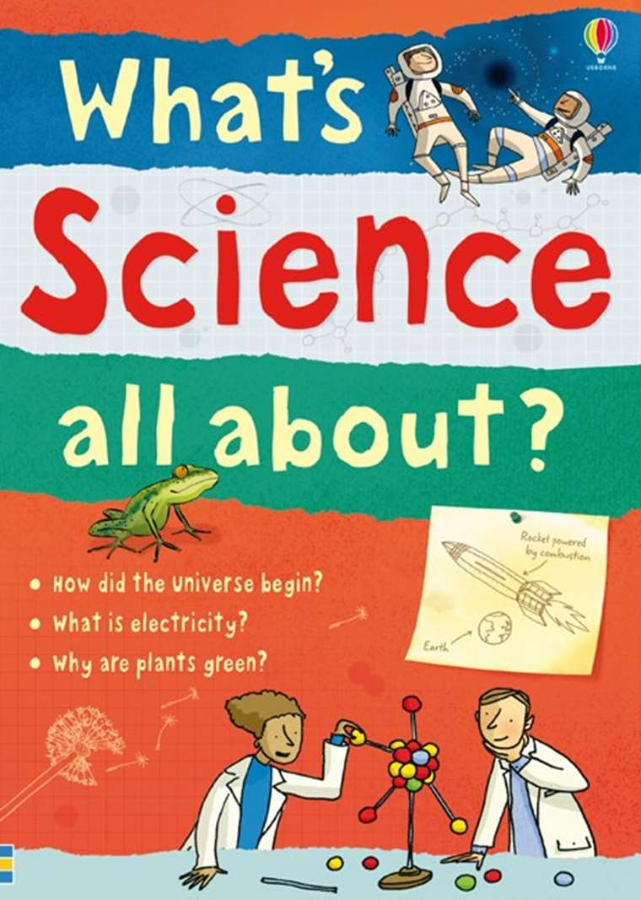
An illustrated guide to physics, chemistry and biology, how they work and how they apply to everyday life.

