GCSE to A-level Task - Physical Geography
Carrying out independent research is a necessary and exciting part of being the best geographer you can be. The best students don’t wait for their teacher to tell them where to find interesting articles. To encourage you to develop an intrinsic interest in geography, we would like you to complete two tasks, which you must bring with you to your first lesson in September. In addition, we would encourage you to begin to navigate the topics in the specification you are going to study over the two year course.
Podcasts can be listened to anywhere, anytime! A favourite podcast of one of the Prospect geography teachers is BBC Radio 4’s Costing the Earth - https://www.bbc.co.uk/programmes/b006r4wn/episodes/downloads
The Guardian has an excellent Environment section, which contains many articles that relate to the specification - https://www.theguardian.com/uk/environment
Your task
Select one article(s) to read and one podcast to listen to (usually around 30 minutes). They must link to an enquiry question/key idea/detailed content from the Geography A-level specification (see below). Make selective notes of no more than one page (font size 11 minimum) for each, including images where appropriate.
The Geography A-level specification we follow (Edexcel) can be found here: https://qualifications.pearson.com/en/qualifications/edexcel-a-levels/geography-2016.html
The article/podcast should relate to Area of study 1 or Area of study 3 (see Contents page). You need to state how it links to the specification – see example given below.
Example:
Fiona Harvey; 18 June 2018; Are we running out of water? The Guardian, available at: https://www.theguardian.com/news/2018/jun/18/are-we-running-out-of-water
Accessed 08/04/20.
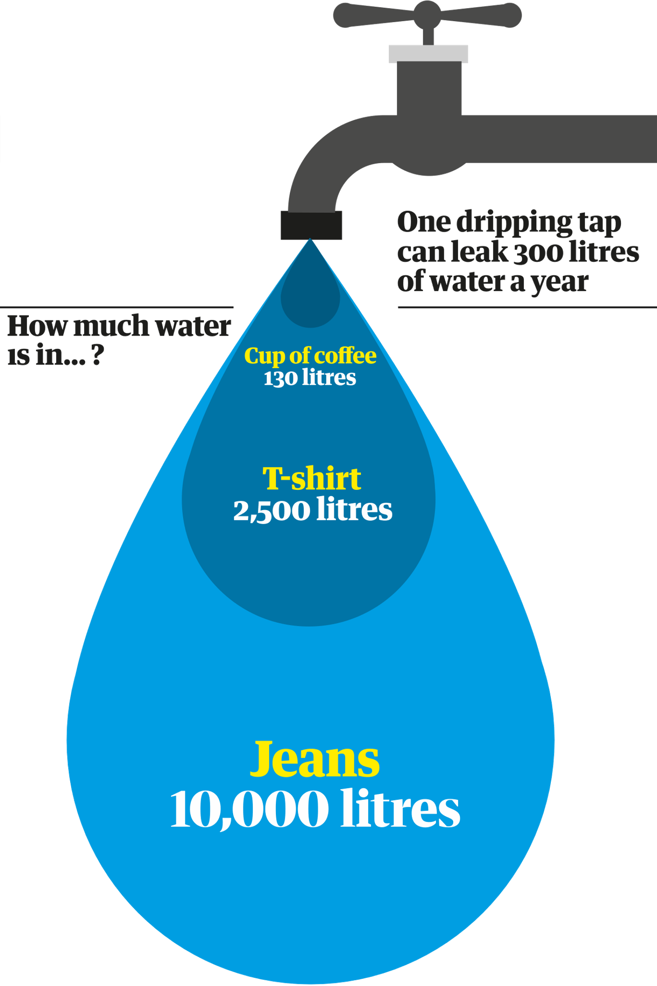
This wide-ranging article links to the specification as follows: Area of Study 1: Physical Systems and sustainability Topic 5: The Water Cycle & Insecurity Enquiry question 3: How does water insecurity occur and why is it becoming such as global issue in the 21st century?
Most of the Earth’s water resources are inaccessible, and those that are accessible are unevenly distributed across the planet. Water is hard to transport over long distances, and our needs are growing, both for food and industry. Everything we do requires water, for drinking, washing, growing food, and for industry, construction and manufacturing. The amount of water needed to produce some goods can be surprising (Figure 1). With approximately 7.5 billion people on the planet, and the population projected to top 10 billion by 2050, the situation is set to grow more urgent.
Figure 1
Currently, about one in nine of the planet’s population, lack access to clean, affordable water within 30 minutes of their homes, and every year nearly 300,000 children under five die of diarrhoea, linked to dirty water and poor sanitation. Providing water to those who need it is not only vital to human safety and security, but has huge social and economic benefits too. Children lose out on education and adults on work when they are sick from easily preventable diseases.
Cape Town in South Africa provided a stark example of what can happen when water supplies come under threat. For years the city was using more water than it could sustainably supply, and attempts to curb wastage and distribute water supplies more equitably to rich and poor had fallen short of what was needed. By late last year, a crisis point had been reached. In the event, the crisis was narrowly averted, in part by public exhortations to use water more efficiently, rationing (Figure 2), changes in practices such as irrigating by night and reusing “grey” water from washing machines or showers, and eventually a new desalination plant.
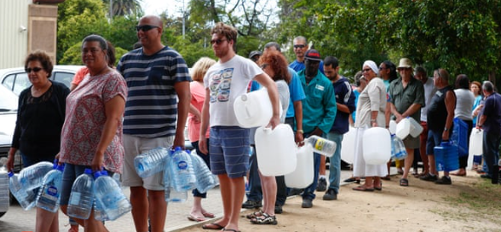
Figure 2
The number of water-scarce areas is increasing: Cape Town is just the beginning. A ground-breaking new study based on data from the Nasa Grace – Gravity Recovery and Climate Experiment – satellites over a 14-year period discovered 19 hotspots around the world where water resources are being rapidly depleted, with potentially disastrous results. They include areas of California, north-western China, northern and eastern India, and the Middle East. Overall, as climate change scientists had predicted, areas of the world already prone to drought were found to be getting drier, and areas that were already wet getting wetter.
According to James Famiglietti, co-author of the Nasa Grace study, some of the most vulnerable areas are “already past sustainability tipping points” as their major aquifers are being rapidly depleted, in particular the Arabian peninsula, the north China plain, the Ogallala aquifer under the great plains of the US, the Guarani aquifer in south America, the north-west Sahara aquifer system and others. “When those aquifers can no longer supply water – and some, like the southern half of the Ogallala, may run out by 2050 – where will we be producing our food and where will the water come from?” he asks.

