Name: Click here to enter text. | Date: Click here to enter a date.

A2 Revision – Children’s Slide
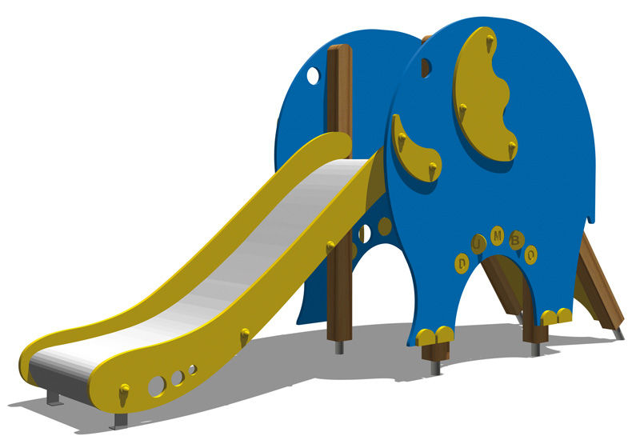
The above Image is of a design for a slide to go in a children’s playground.
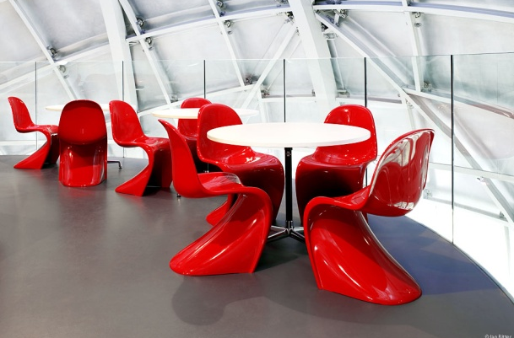
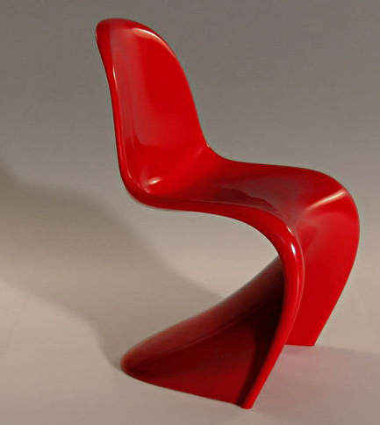
1) Explain the main criteria that you believe should be used in the design of such items.
Click here to enter text.

2)Using the criteria you have given above, critically evaluate the design of the slide.
Click here to enter text.

